_

Accessibility Guide for Ford & Etal Estates
tourism@ford-and-etal.co.uk
www.ford-and-etal.co.uk

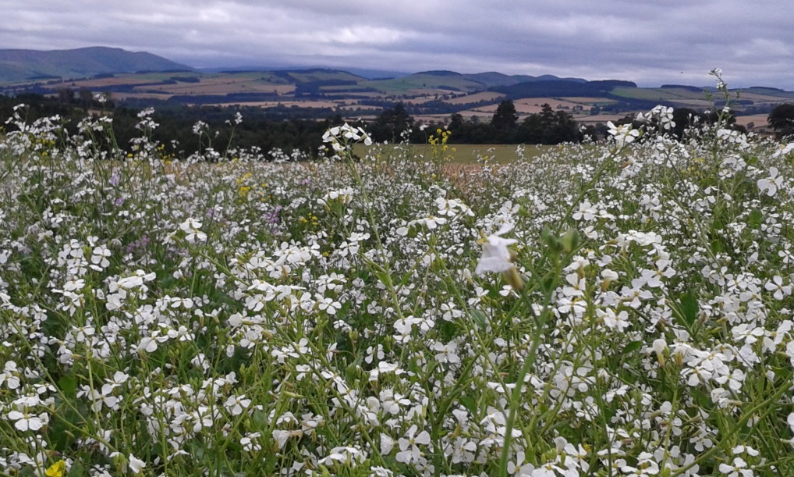

Welcome
Ford & Etal is a traditional working estate covering approximately 16,000 acres of countryside which can be accessed via public and permissive footpaths and bridleways, and within which there are a number of visitor attractions and activities offering a range of educational and leisure pursuits for all ages and abilities. Ford & Etal Estates aims to provide a high quality experience to all our visitors by giving them such a warm welcome and enjoyable experience that they will leave with good memories, return for further visits and recommend Ford & Etal to others.
Due to the nature of the estates some locations and venues are not accessible to all. We hope that this guide provides the information that you require however please contact us if you require any further information or advice on planning your visit. We will assist as far as we can although it may be necessary for you to contact individual venues about specific access issues.
We strive to continually improve our visitor services and welcome your feedback to help us with this. If you have any comments please get in touch by telephone or email. Please note however that most of the attractions and businesses operating on the estate are independent enterprises over which the Estates have no direct management control.

Getting here

Visitor Centre Ford Village Etal Village Hay Farm
Heatherslaw Berwick-upon-Tweed Cornhill-on-Tweed Cornhill-on-Tweed
Cornhill-on-Tweed Northumberland Northumberland Northumberland
Northumberland TD15 2QG TD12 4TN TD12 4TR
TD12 4TJ

Travel by Car
Ford & Etal Estates are:
- 30 minutes (12 miles) south-west of Berwick-upon-Tweed
- 20 minutes (8 miles) north of Wooler
- 45 min (25 miles) north of Alnwick
- 1hr 15 min (60 miles) north of Newcastle

From the North by the A1 via the B6354 approx. 12 miles south west of Berwick-upon-Tweed - follow the brown signs from the Berwick-upon-Tweed A1 bypass to Ford & Etal.
From the North by the A697 Follow the brown signs for Ford & Etal approximately 6 miles south of Coldstream.
From the South by the A1 Follow the brown signs from the A1/B6353 Fenwick junction for approximately 9 miles.
From the South by the A697 Follow the brown signs after Milfield, turning off at the B6354.
Cycle Route 68
Sustrans Cycle Route 68 (Berwick-upon-Tweed to Derbyshire) passes through the estate. Cycle racks are located at Heatherslaw Mill, outside Lady Waterford Hall in Ford and at Lavender Tearooms in Etal.
Public Transport
- Bus service 267 (Border Buses) operates between Berwick-upon-Tweed and Wooler, stopping at Etal, Heatherslaw and Ford. This is a limited service and there are no buses on Sundays and Bank Holidays.
- The nearest railway station is Berwick-upon-Tweed.
- Taxis can be pre-booked with Border Villager (tel 01668 482888; email scott@bordervillagertaxi.co.uk)

Arrival
The Ford & Etal leaflet describes the main facilities, attractions, travel directions, opening times/dates and where an admission charge applies. This leaflet is widely distributed to other tourism venues, including holiday accommodation, camp sites and Tourist Information Centres and so it can be viewed prior to visiting. More detailed information can be found on our website, our social media channels and in the individual leaflets produced by some of the attractions. There is a guide to the history of the area Ford and Etal: Glimpses from bygone days which can be purchased from local venues.
Explore our website to find out more about what there is to see and do in the villages of Ford, Etal and the hamlet of Heatherslaw. There is a Visitor Centre at Heatherslaw so this is a useful first point of call to obtain information about all there is to see and do.
Estates signage indicates the location of attractions, toilets etc. as well as demarcating areas which are not open to the public, such as private houses and gardens. There are also a number of brown tourist signs. Large map boards (not to scale) showing the location of places to visit can be found in Etal, Heatherslaw and Ford.

Parking
Car parking is free throughout the Estates and is accessible to the disabled, with designated disabled parking spaces at certain locations (see below for details).
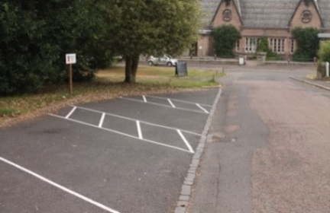 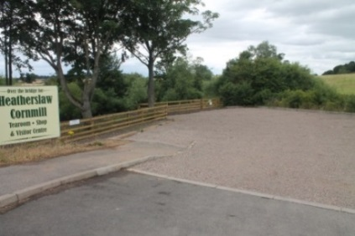 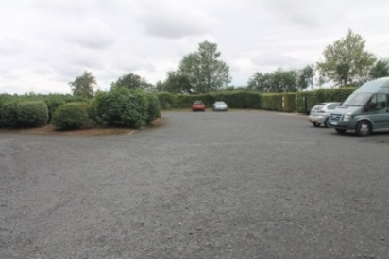
Car parking in Ford Car park east of river, Heatherslaw Car park adjacent Etal Castle
Etal:
There are two public car parks in the village – one behind the Village Hall and the other adjacent to Etal Castle; both are graveled and level. There is a designated disabled parking bay for Village Hall users. Please use these car parks wherever possible.
Ford Village:
Parking is available directly outside all venues, on the road side. There is also a tarmac lay-by on the opposite side of the road to Ford Shop, with marked parking bays including one blue-badge holder space. The road/lay-by is on a moderately steep slope, downhill towards Lady Waterford Hall. The Old Dairy has its own car park.
Heatherslaw:
There are two car parks with deep gravel on the east side of the river, accessed from the B6354: one at Heatherslaw Railway (flat surface with parking adjacent to ticket office), and one adjacent to the railway car park (flat surface with 15 parking spaces). The iron bridge leading across to the Mill and Visitor Centre from the car parks is for pedestrian and bicycle use only.
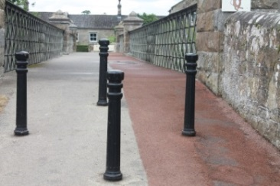
Bridge leading to Heatherslaw Cornmill
The walk from the car park across the bridge to Heatherslaw Cornmill is approximately 200 metres. There are 4 bollards at each end of the bridge to prevent vehicles crossing; these are in a diamond layout which provides a 1.7metre gap (suitable for push chairs and wheelchairs). The bridge is covered with a non-slip decking, designating a cycle lane and pedestrian lane. The bridge can be used by wheelchairs and mobility scooters.
On the west side of the river there is access to Heatherslaw from the B6353 on the stretch between Crookham village and Ford Bridge, look for the 'Dead End' sign. Turn here and follow the road for about a mile to the Heatherslaw Mill site. There are two disabled spaces adjacent to the Visitor Centre and a large car park which is signposted. Visitors are advised to telephone in advance if they have any queries about this access. There is a car charging point behind the Visitor Centre which can be used by visitors to the Estates.

Venue Information – Ford Village

Lady Waterford Hall
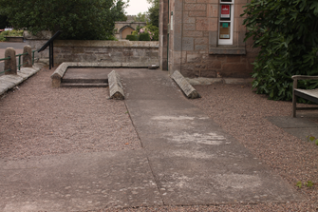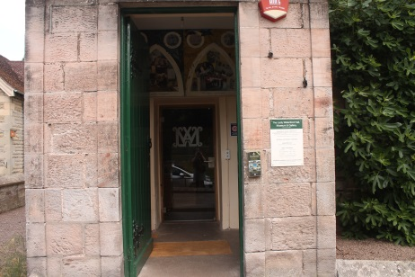
Ramped access to Lady Waterford Hall Entrance lobby & glass door
The Hall is a Grade II* Listed Building and a registered Museum at ground floor level, accessed from the pavement by a concrete path and gently sloping ramp. There is a glass door 90cm wide with contrasting markings in the centre. There is a fully accessible WC with automatic light and grab rail on inside of door at 70cm. The wash hand basin is 84cm high with ‘touch free’ tap and grab rails at either side; toilet height 47cm; moveable double horizontal rail to right of toilet at 70cm high (top rail) and vertical handrail fixed to wall to left of toilet at 70cm. Electric hand drier at 1m 12cm.
There is no hearing loop in the Hall. Interpretation panels are fixed on the wall at standing eye level and there are information panels in the centre of the Hall 110cm high. There is an audio talk available. The floor in the main hall is wooden boards; in the ante-room it is carpet. In the toilets and linking vestibule there is a non-slip floor covering.
The Hall has a retail area selling gifts and cards as well as pamphlets and books about Louisa Waterford and her artwork. The Hall is also available for private hire – email ladywaterfordhall@ford-and-etal.co.uk or telephone 01890 880007.

Ford Village Shop/Sub-Post Office/Tearoom
There is one step into the shop area and a further two steps into the Tearoom. A ramp to access the shop is available on request. Refreshments are served inside and outside on the patio where there are tables and chairs. Access from the road is via a flagstone path which joins the village footpath. There is a dropped kerb from the road below the shop.
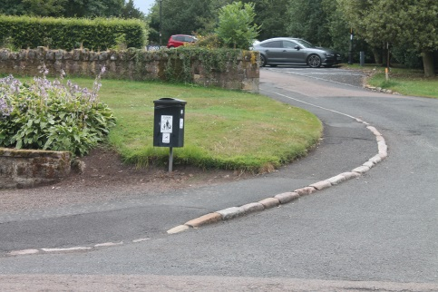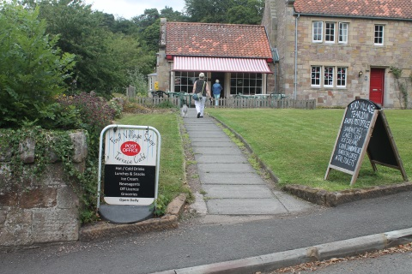
Dropped kerb – main street below Ford Shop Entrance path to Ford Shop
There is one small WC for use by patrons of the tearoom. This is not disabled accessible. The Sub-Post Office is open Monday-Friday 0830-1230. There is a defibrillator on the outside wall of the shop.

Ravn Clay Pottery
Built after World War One, The Reading Room was a built as a quiet space for ex-servicemen to relax. In 2022 Ravn Clay Pottery moved into the building. There is a gallery, and a space for workshops. There are three steps down from the pavement to the access path and three steps up from the path to the entrance. There is a toilet for workshop customers, but there is a step into the toilet.
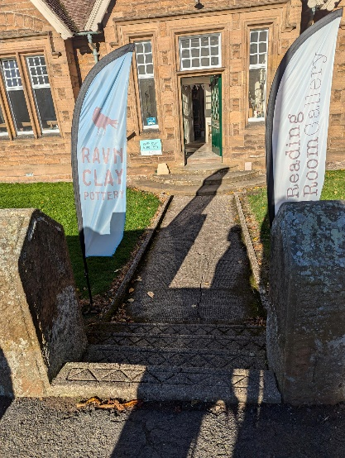
Ravn Clay Pottery entrance

The Old Dairy/Restoration Coffee Shop
Located just outside the centre of the village, opposite St Michael and All Angels Church, there is wheelchair access from the main car park via a small road past the dairy buildings from which all buildings and the summer house can be accessed. There are toilets for customer use but these are not wheelchair accessible. Dogs are not allowed on these premises.
The Old Forge
Ground floor level access from the street, space inside is very limited.
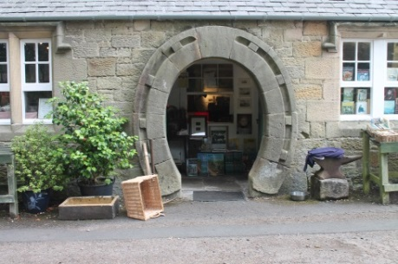
Entrance to The Old Forge

Accommodation in Ford
Ford Village Shop offer Bed & Breakfast accommodation. This is not wheelchair accessible.

Children’s Play Park
There is a playpark in Ford located down the hill past the Old Forge on the left. There is a Spider Log Climber, a Thumper Tower, a Log Basket Swing, a Time out Trail and Nursery Swings. These facilities were provided and are managed by Ford & Etal Parish Council.

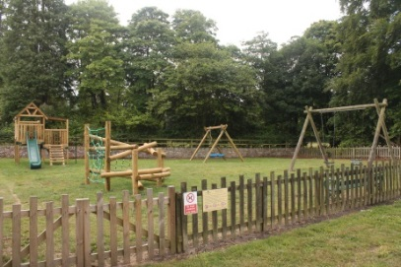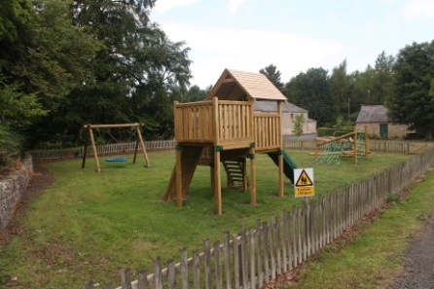

Venue Information – Etal Village

Etal Castle
There is free entry to the castle ruins either via the portcullis, which is not suitable for wheelchair users, or from the castle car park there is a level entrance. The grounds of the castle are grassed and, whilst accessible, care should be taken as some areas are uneven and sloping, and grass can be slippery in wet weather. The nearest public toilets are in the adjacent car park.
Heatherslaw Railway Terminus at Etal
There is a moderately steep sloped path, uneven in places, from the terminus to Etal Castle. There is a wooden handrail on one side all the way along the path. At the gate through to Etal Castle there is a tarmac ramp and some uneven cobble stones.
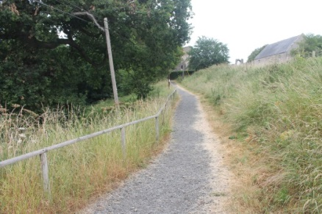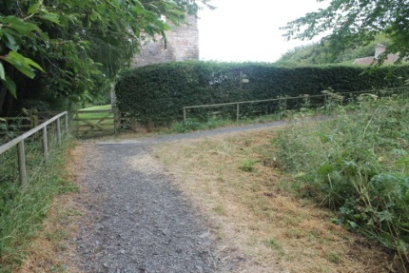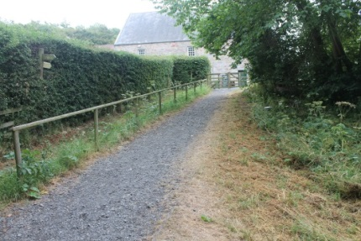
Path from Heatherslaw Railway Terminus to Etal Castle
Etal Shop/Sub-Post Office/Lavender Tearooms
Access from the street is level. There is a step into the building. A ramp to access the shop and tearoom is available on request. The Sub-Post Office is open Monday-Thursday 0900-1300. Refreshments are served inside and outside where there is a large paved area to the front of the building with a level access. There are toilets (not wheelchair accessible) and baby changing facilities for patrons of the Lavender Tearooms.
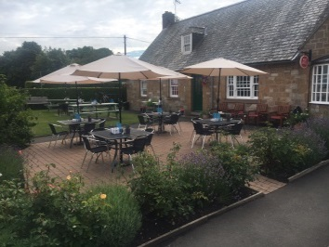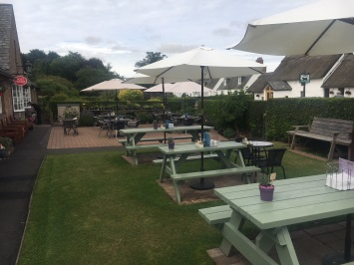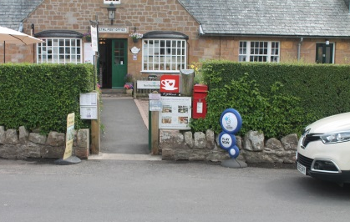
Tea Garden, Lavender Tearooms Entrance from road, Etal Shop/Tearoom
The Black Bull
There is a designated disabled parking bay to the front of the Black Bull. There is a dropped kerb and the entrance is level, with a wide door leading into the bar area. There is a fully accessible WC in the pub’s rear hall. There are two steps from the bar to the restaurant area, however the restaurant seating can be accessed from the rear of the building. A path leads from the street along the side of the pub to the beer garden and rear access.
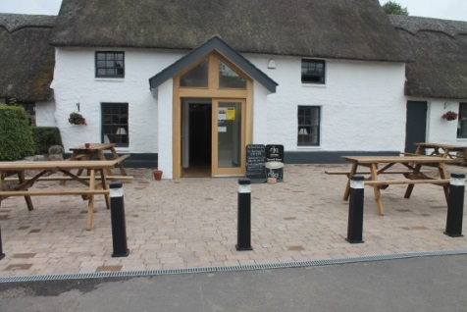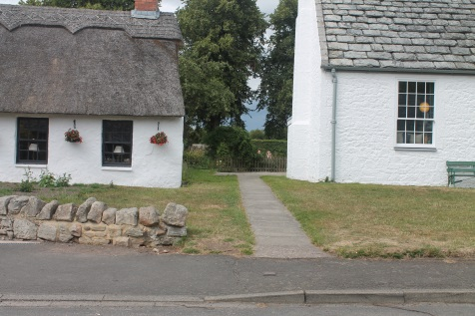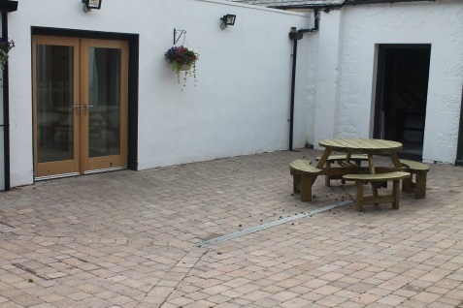
The Black Bull, Etal – front entrance Path to rear entrance/beer garden The Black Bull, Etal - rear entrance

Etal Village Hall
Etal Village Hall is available for private hire. The hall is fully accessible with a purpose-fitted accessible WC. Facilities include main hall with projector, high quality DVD player, and surround sound system; Small Hall, fully fitted catering kitchen; broadband connection with Wi-Fi; seating for up to 80; children’s tables & chairs.
There is a defibrillator inside the hall and an electric car charging point outside.

Venue Information – Heatherslaw

Heatherslaw Light Railway Station
The ticket office/shop is wheelchair accessible – entry and exit via the station platform. The train has some accessible carriages suitable for wheelchairs and prams. It is advisable that wheelchair users telephone 01890 820244 prior to visiting in case these carriages are already booked. The Railway publishes a timetable detailing train times and prices. There are no toilets at the station – the nearest toilets are located just across the bridge on the Heatherslaw Cornmill site. The car park has an uneven stony finish, this area floods regularly so it cannot be tarmacked.
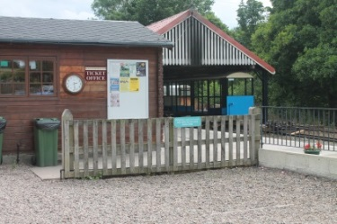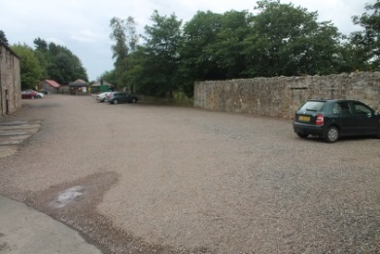
Ticket Office/level entry to station platform Car Park Heatherslaw Light Railway

Heatherslaw Cornmill & Gift Shop
The building which houses the Mill, Gift Shop and Tearoom is a Grade II* Listed Building and a registered Museum. It is accessed by stone steps. There are seven steps with metal handrail leading to the Shop & Mill entrance. The Mill is built over three floors, access at middle floor. Basement and top floors are accessed via an open wooden staircase, even treads, eight steps in each flight, handrails on both sides.
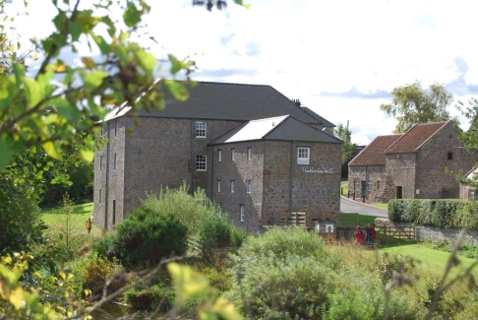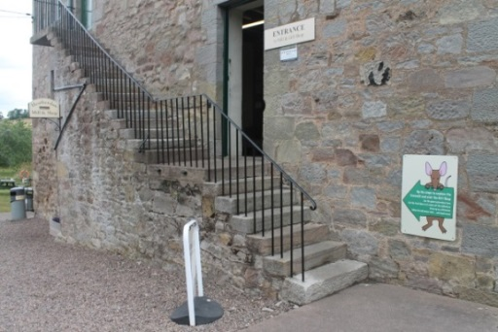
Heatherslaw Cornmill Entrance to Mill & Gift Shop
Heatherslaw Cafe
Located within the Mill building the tearoom is accessed by stone steps – five steps down with metal handrail to the entrance lobby then ten steps up with a wooden handrail. There are toilet and baby changing facilities on the top floor but these are not disabled accessible. If visitors are unable to access the tearoom then refreshments are served at one of the picnic tables outside.
Heatherslaw Visitor Centre
At ground floor level, the Centre is fully accessible with a double door opening to 140cm allowing wheelchair access. Interpretation boards are mounted on the walls. A range of leaflets describing walks and cycle routes around the Estates and things to do in the local area are available. There is a sandpit in the meadow beside the mill and visitors who wish to have picnics are welcome to use this space. The Visitor Centre is not staffed, if you have a query the Visitor Services office is nearby, call 01890 820338.

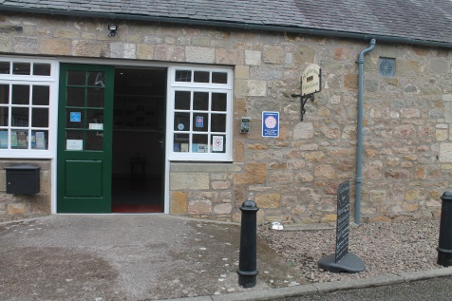
Entrance to the Visitor Centre

Handmade at Heatherslaw
There is a step up from the road onto the kerb then a level entrance into the shop, doorway 90cm wide. A ramp is available on request. NB the door is very low.
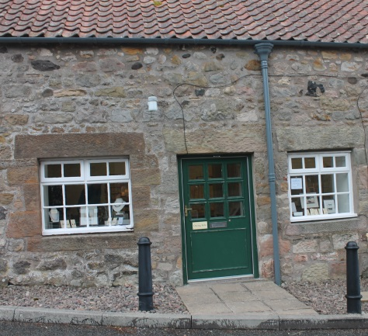
Entrance – Handmade at Heatherslaw

Venue Information – Hay Farm Heavy Horse Centre

The Centre buildings, including the shop and tearoom, are wheelchair accessible being at ground floor and/or accessed via a ramp. There is a car park within the Centre and a tearoom and a toilet.
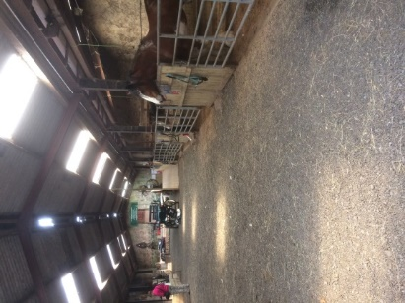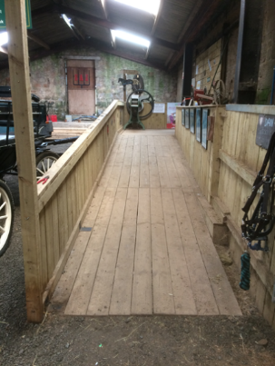
The main stable, Hay Farm The ramp to the main stable, Hay Farm

Accommodation
There are a number of bed and breakfast establishments and holiday cottages across the Estates, all run independently. Ford Bridge Campsite, a small, designated camping/caravan site opened in 2020 and Cheviot Glamping recently opened at Slainsfield, near Etal, beside Cheviot Brewery and Cheviot Tap. See Ford & Etal website for contact details/further information. Wild Plum has one large property, Housden Haugh, with special facilities for disabled guests, further details on our website.

Public Areas

There are public toilets in each village (open beginning of April to end of October) and some venues have toilets for use by their own customers. There is also a portaloo cubicle (open seasonally) adjacent to Ford Moss Nature Reserve.

Public toilets in Heatherslaw (April – October 10:00-17:00/16:00 in Oct)
At Heatherslaw there are two unisex public toilets adjacent to the Visitor Centre. These are accessed from the road where there is a dropped kerb onto the concrete path. Wheelchair users can access the toilets independently. The door width is 87cm; toilet seat height 42cm; washbasin height 83cm. Each toilet has a horizontal support rail beside the toilet, at 80cm high. Both toilets have a fold down baby-changing table.
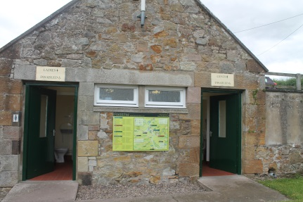
Toilet entrances at Heatherslaw

Public toilets in Etal Castle car park (April – October 10:00-17:00)
Etal Village has two unisex compostable public toilets in Etal Castle car park, one is accessible by wheelchair. This larger toilet is accessed from the car park and is clearly signed. The door is 96cm wide, There is one horizontal handrail 48cm to the left of the toilet, rail height 80cm. The hand basin is 72cm high and has a cold-water tap. The toilet seat is 40cm high. There is no alarm call system. The other toilet can also be accessed from the car park or via a path down the side of The Old Chapel. There are no baby changing facilities in these toilets.
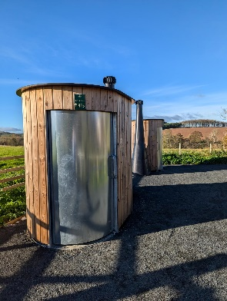
Accessible compostable toilet
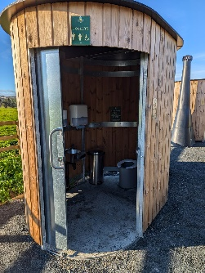

Public toilets in Ford village (April – October 11:00-17:00/16:00 in Oct)
Ford Village has two unisex public toilets situated in a small lane to the rear of Ravn Clay Pottery and Lady Waterford Hall, one is accessible by wheelchair. The toilets are clearly signed. The door to the accessible toilet is 74cm wide, there is one horizontal handrail and one vertical handrail to the immediate left of the toilet, rail height 72cm. The hand basin is 74cm high and has a cold-water tap. The toilet seat is 41cm high. There is no alarm call system. The other toilet can also be accessed via the same path via the right fork. There are no baby changing facilities in these toilets.
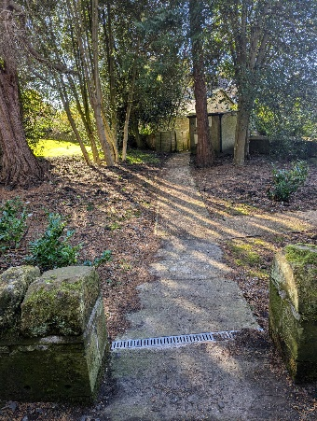
Path to the accessible toilet in Ford
Ford & Etal Estates outside areas and grounds
Many footpaths, bridleways and permissive paths criss-cross the Estates land. Maps and descriptions of routes are available from Heatherslaw Visitor Centre or can be downloaded from the Ford & Etal website. These paths are clearly way-marked using colour-coded markers. All public footpaths and bridleways are shown on OS Explorer Map 339 (Kelso, Coldstream & Lower Tweed Valley). As the paths run through fields and moorland many areas are unsuitable for those with mobility difficulties and are not generally wheelchair accessible. Staff at the Visitor Centre Office can advise (Telephone 01890 820338) and our other attractions and venues are also always happy to be of assistance.
Route 68 Berwick-Derby national cycle route passes through the Estate and there is a dedicated, off-road section running from Tindal House to Etal Village (approx 2 miles, some hills) and from Slainsfield road end to Heatherslaw (approx ½ mile, level). These paths are used by walkers and cyclists and are accessible to wheelchair users.
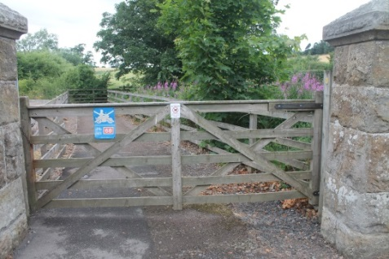
Entrance to Route 68 cycle way/footpath from Heatherslaw to Etal
Picnics
Wooden picnic benches are located at Etal Castle and near the river at Etal. Visitors who wish to have picnics near Heatherslaw Mill are welcome to use the fenced-off paddock beside the mill. The picnic tables outside the café are reserved for customers. No barbecues are allowed on Ford & Etal Estate land.
Benches are located in Ford Village outside Lady Waterford Hall, and in the play park situated on the left past The Old Forge. In Etal there are benches outside the village hall.

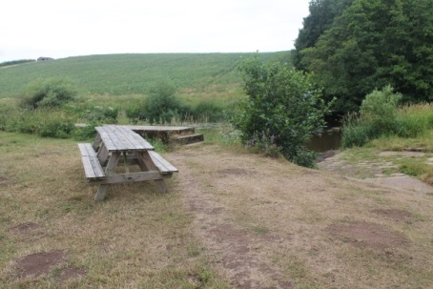
Picnic Benches by the river at Etal
Grass areas in all the villages are regularly mown and available to the public as play/picnic areas.

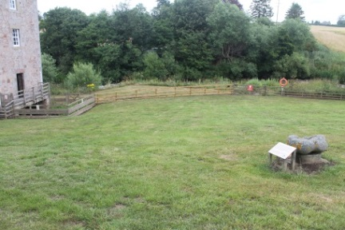
The Paddock at Heatherslaw
Litter
Litter bins/dog poo bins are located at various locations in Etal and Ford villages, on the Heatherslaw Mill site and in the two car parks on the Railway side of the bridge. Please pick up your litter and dispose of it in the public bins provided.
Dogs
Dogs are welcomed onto the Estate but must be kept on a lead at all times. Service dogs are welcome in all venues. Dogs are welcome on Heatherslaw Light Railway, at Etal Castle, at Hay Farm Heavy Horse Centre, in Lady Waterford Hall, in Ford Village Shop, the bar areas at The Blue Bell (Crookham) and The Black Bull (Etal), in Heatherslaw Gift Shop (but not inside the working mill), the Visitor Centre, Heatherslaw Tearoom and in Handmade at Heatherslaw. Dogs are also welcome in the gardens/outside areas at Lavender Tearooms.
Water bowls are provided for dogs in all villages. If you run out of poop scoop bags there are emergency ones available free-of-charge in Heatherslaw Visitor Centre. Dog waste bins are located in Ford, Etal, Heatherslaw and at Ford Bridge. Please pick up after your dog and dispose of waste in one of the bins provided.

When visiting Ford & Etal Estates please observe the Countryside Code

Guide last updated: 31st October, 2024

